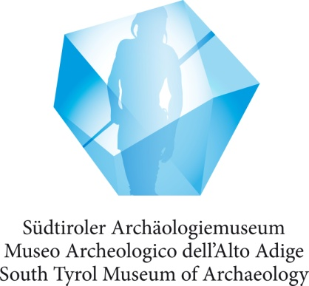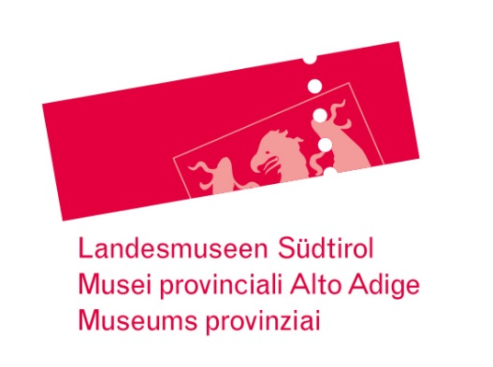
Press Release
Bozen-Bolzano, June 20, 2018

Press photos and text download: http://www.iceman.it/en/press-area/press-releases/
Contact: Katharina Hersel, Press Office, South Tyrol Museum of Archaeology, Tel. +39-0471-320114, eMail: press@iceman.it

Ötzi’s lithic raw materials from Northern Italy
The “chert” research project proves the existence of wide-ranging trading connections in the Copper Age

Bozen-Bolzano – A man on the run, who not only has to overcome adversaries, but also a shortage of lithic raw material: this would be one way to characterise Ötzi’s situation shortly before his death. A team of researchers working with the South Tyrol archaeologist Ursula Wierer has been studying the flint (chert) artefacts of the famous glacier mummy in a wide-ranging interdisciplinary research project. The results, published today (june 20, 2018) in the scientific journal PLOS ONE* describe how Ötzi maintained his personal toolkit and allow further insights into the wide-ranging trading connections of a Copper Age community on the southern slopes of the Alps, in today’s South Tyrol. They were even able to fill in some of the gaps in the as yet unsolved mystery as to what happened in the last few days of Ötzi’s life.

Ötzi the Iceman took a compact chert toolkit with him when he made his way up the 3210 m high Tisen yoke (Schnals Valley, Italy). His survival kit included a dagger with a very short blade and broken tip, as well as only two arrow heads for the 14 arrows in his quiver. In his belt pouch there was an end-scraper and a borer, both heavily worn down, as well as a small flake and, not to forget his retoucher (pressure flaker), a unique device not found in this form anywhere else, which would have been used to retouch and resharpen the tools. Useful for comparison has been also the CT images of the deadly arrow head which still remains in situ in Ötzi’s shoulder.
Experts from South Tyrol, Italy and France studied the chert raw material and the Technology of tool production, both macroscopically and microscopically as well as through CT-analyses, and they investigated the wear traces caused by use of the instruments, by undertaking dedicated experiments amongst others, and compared the shape of the tools with those used by related cultures.
The origin of the chert in Ötzi’s toolkit could be documented in detail for the first time and located topographically by using the “lithoteque” (rock collection) at the University of Ferrara Italy. This showed that the chert in five of the six items came from the so-called Trento Plateau, which covers a wide area between Trentino and Veneto. Amongst these, they were able to narrow down the origin of one of the arrow heads to Non Valley (Trentino, Italy; linear distance from the Iceman’s finding spot at Tisen yoke: 70km). Surprisingly, the chert of the dagger originates from the slope between the Trento Plateau and the Lombard Basin, or these days, the western Trentino and eastern Lombardy. This tells us that Ötzi’s community - as had already been demonstrated by his copper axe blade which originated from Tuscany - had extensive trading links to different, distant areas, which would have secured them the necessary chert supplies.
The shape of Ötzi’s arrow head corresponds to the typology of North Italian findings. The influence of the Swiss Horgen culture is evident in the endscraper. This should however come as no surprise, as the South Tyrol valleys at the end of the fourth century BCE had access to transalpine contacts and to a lively exchange of goods and ideas.
The new investigation also demonstrated the working techniques that Ötzi and his contemporaries used to produce lithic tools and, when necessary, using the pressure techniques, were able to re-sharpen them repeatedly. Almost all of his tools show strong wear traces on the tool edges. From these traces one can determine the direction of the working process and the materials involved. Ötzi used the tools above all for cutting siliceous grasses such as grain and other wild plants.
From the use-wear on the endscraper and retoucher the research team were also able to show that Ötzi was right-handed. From this they were able to deduce that the completed arrow with the feather fletching wound to the left could not have been made by Ötzi, but by another person.
The Iceman was not a professional flint knapper, but he was certainly in the position to re-sharpen his tools and increase their life-cycle. Evidently Ötzi had not had any access to new chert material for a considerable time. This state of affairs meant that in the last few hectic days of his life, which were probably marked by flight and pursuit, he was greatly restricted in what he could do, as it prevented him from repairing his toolkit and from producing new arrowheads.
Two freshly re-sharpened tools demonstrate careful maintenance of his tool kit, even though they were both nearly at the end of their useful life. They also allow us to presume that he had planned to undertake work with them, work which he was not able to carry out. Was this because of the severe cut to his hand which has recently been discovered? Or because of his hasty departure up into the high mountains? It was there that he was murdered by an arrow shot, which used an arrow head of a southern Alpine type such as was in use in his own circle. The arrowhead remained buried in Ötzi’s shoulder as the only evidence that there had indeed been a murderer at work.

The research project was initiated and financed by the South Tyrol Museum of Archaeology. The interdisciplinary research team, which was coordinated by Ursula Wierer (Soprintendenza Archeologia, Belle Arti e Paesaggio di Firenze), included Simona Arrighi (University of Siena), Stefano Bertola (University of Ferrara / University of Innsbruck), Günther Kaufmann (South Tyrol Museum of Archaeology), Benno Baumgarten (South Tyrol Natural History Museum), Annaluisa Pedrotti (University of Trento), Patrizia Pernter (Central Hospital Bozen-Bolzano) und Jacques Pelegrin (University of Paris Nanterre).

QUOTES
Ursula Wierer, Project Leader: “What we do is to examine tools from the past and reconstruct their life cycle in detail, from their production to their utilisation until they were finally discarded. In this way we are able to determine many features of the lifestyle of prehistoric people. In Ötzi’s case we were dealing with the toolkit of a specific person, about whom we already knew a great deal. This made the research all the more exciting.”
Angelika Fleckinger, Director of the South Tyrol Museum of Archaeology: “We decided to have the entire set of chert tools found with the Iceman re-evaluated by experts, as the possibilities for scientific research have been considerably enhanced over the 25 years since the original discovery. In so doing it was very important for us to shed light on different aspects: specifically a clear identification of the areas where the chert came from, more detailed information about the production and use of the tools, but also the scientific documentation. This present article means that extensive details about the chert tools of the Iceman have now been published.”

Interviews: The archaeologist Ursula Wierer will gladly answer any questions via email: ursula.wierer@beniculturali.it; mimmurs@hotmail.com or telephone. +39 333 2706996.

*LINK to the ORIGINAL ARTICLE:
http://journals.plos.org/plosone/article?id=10.1371/journal.pone.0198292

Photos: © South Tyrol Museum of Archaeology/name of the photographer (see digital file)
Lack of fresh supplies of this all-round chert material compelled the Iceman to exploit the substance and functionality of his lithic tools to their absolute limits.

Press contact:
Katharina Hersel
South Tyrol Museum of Archaeology
Museumstr. 43, I-39100 Bozen-Bolzano
T +39 0471 320114, F +39 0471 320122
press@iceman.it, www.iceman.it
Facebook: OetziTheIceman

